Circuit symbols

Match the symbol to the electrical component it represents.

Symbol |  | Component
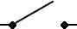 |  | ammeter
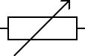 |  | cell
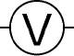 |  | battery
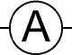 |  | voltmeter
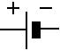 |  | variable resistor
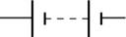 |  | motor
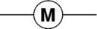 |  | bulb
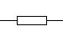 |  | switch
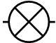 |  | resistor

